Ex.No: 5b | DATA VISUALIZATION USING MATPLOTLIB

AIM:
To create and analyze various data visualizations such as Line Charts, Bar Charts, Pie Charts, Histograms, Scatter Plots, and Box Plots using Matplotlib for effective data interpretation.

ALGORITHM:
Step 1: Start.
Step 2: Import the required libraries
Step 3: Create the monthly sales dataset or load it from a CSV file.
Step 4: Store the data in a Pandas DataFrame.
Step 5: Display the dataset to verify that it has loaded correctly.
Step 6: Create the required visualizations:
- Line Plot
- Bar Chart
- Scatter Plot
- Histogram
- Box Plot
- Pie Chart
Step 7: Add appropriate:
- Title
- X-axis label
- Y-axis label
- Legend (if needed)
Step 8: Display each graph using plt.show().
Step 9: Analyze the visualizations to identify:
- Sales trends
- Highest sales month
- Lowest sales month
- Distribution of sales values

Program:

Line plot:
import pandas as pd
import seaborn as sns
import matplotlib.pyplot as plt

df = pd.read_csv("Social_Media_Engagement.csv")

plt.figure(figsize=(8,5))

plt.plot(df["Follower Count"], df["Engagement Rate"])

plt.title("Line Plot: Follower Count vs Engagement Rate")

plt.xlabel("Follower Count")

plt.ylabel("Engagement Rate")

plt.grid(True)

plt.show()
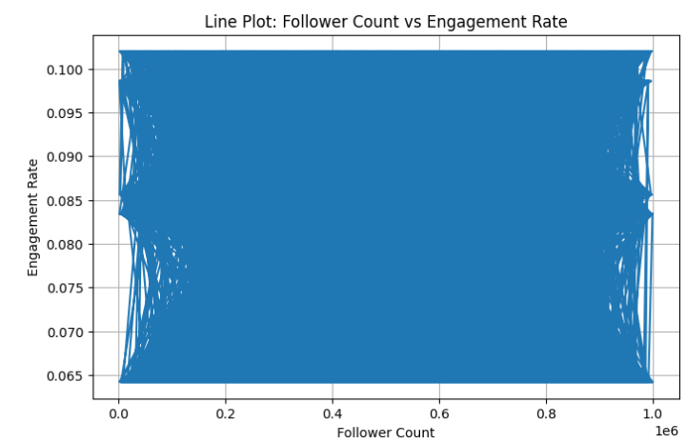
Box plot:
plt.figure(figsize=(6,5))

plt.boxplot(df["Engagement Rate"])

plt.title("Engagement Rate Box Plot")

plt.ylabel("Engagement Rate")

plt.show()
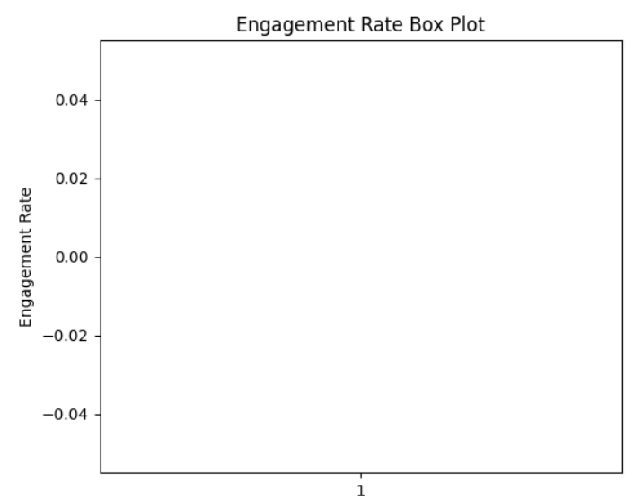

Histogram:
plt.figure(figsize=(8,5))
plt.hist(df["Follower Count"], bins=15, edgecolor="black")
plt.title("Follower Count Distribution")
plt.xlabel("Follower Count")
plt.ylabel("Frequency")
plt.show()
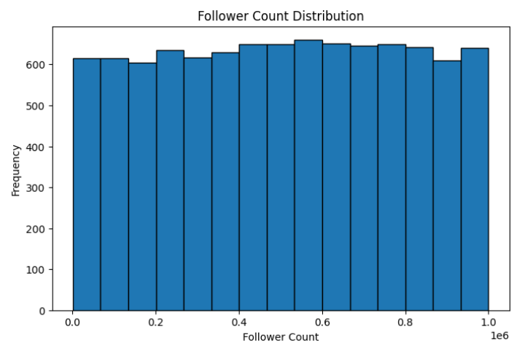
Violin Plot:
plt.figure(figsize=(6,5))

plt.violinplot(df["Engagement Rate"])

plt.title("Engagement Rate Violin Plot")

plt.ylabel("Engagement Rate")

plt.show()
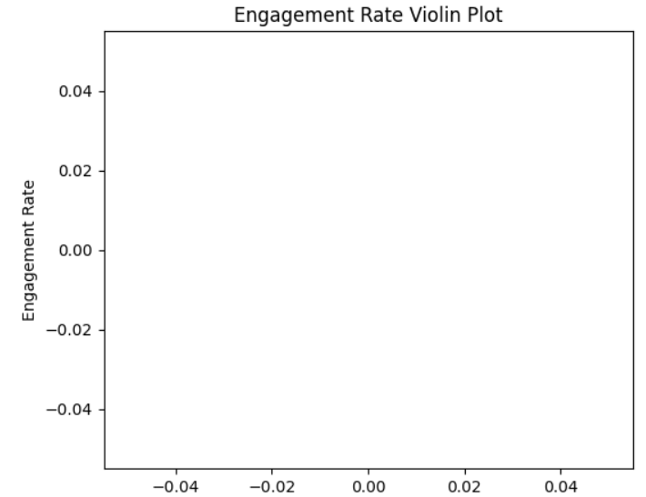

plt Plot:
plt.figure(figsize=(10,5))

plt.plot(df.index, df["Engagement Rate"])

plt.title("Engagement Rate Trend")

plt.xlabel("Record")

plt.ylabel("Engagement Rate")

plt.grid(True)

plt.show()
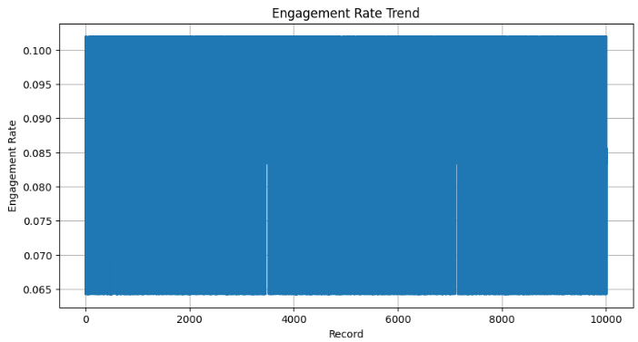

Stackplot:
plt.figure(figsize=(10,5))

plt.stackplot(
df["Account ID"],
df["Follower Count"],
df["Campaign Reach"],
labels=["Follower Count", "Campaign Reach"]
)

plt.title("Follower Count and Campaign Reach")

plt.xlabel("Account ID")

plt.ylabel("Values")

plt.legend()

plt.show()

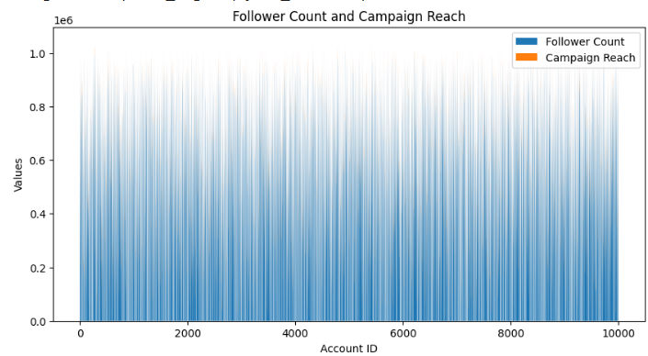
Rotation:
plt.figure(figsize=(12,5))

plt.plot(df["Account ID"], df["Engagement Rate"])

plt.xticks(rotation=45)

plt.title("Engagement Rate by Account ID")

plt.xlabel("Account ID")

plt.ylabel("Engagement Rate")

plt.tight_layout()

plt.show()

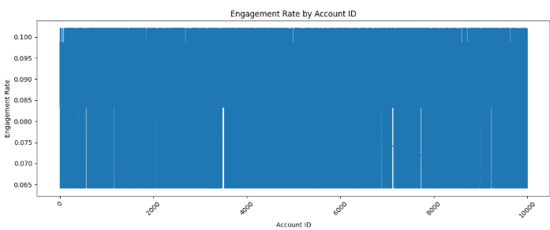

Pie chart:
platform = df["Platform"].value_counts()

plt.figure(figsize=(7,7))

plt.pie(
platform,
labels=platform.index,
autopct="%1.1f%%",
startangle=90
)

plt.title("Platform Distribution")

plt.show()
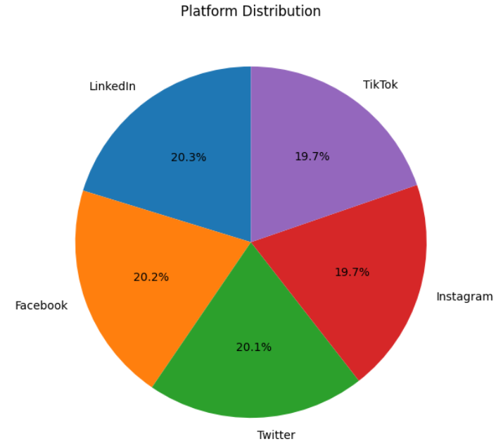

Multiple Plots:
fig, ax = plt.subplots(2,2, figsize=(12,8))

ax[0,0].plot(df["Account ID"], df["Engagement Rate"])

ax[0,0].set_title("Line Plot")

ax[0,1].hist(df["Follower Count"], bins=15)

ax[0,1].set_title("Histogram")

ax[1,0].boxplot(df["Engagement Rate"])

ax[1,0].set_title("Box Plot")

ax[1,1].scatter(df["Follower Count"], df["Campaign Reach"])

ax[1,1].set_title("Scatter Plot")

plt.tight_layout()

plt.show()
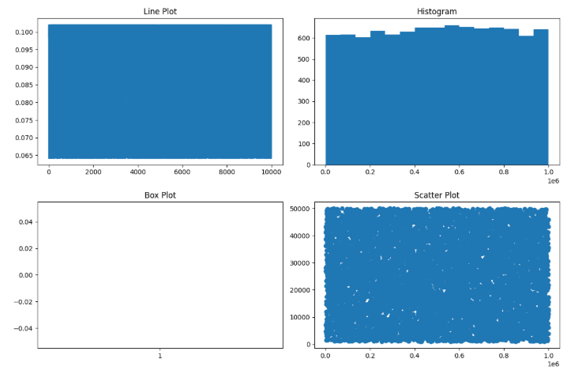

Scatter plot:
plt.figure(figsize=(8,5))

sns.scatterplot(
data=df,
x="Follower Count",
y="Campaign Reach"
)

plt.title("Follower Count vs Campaign Reach")

plt.show()
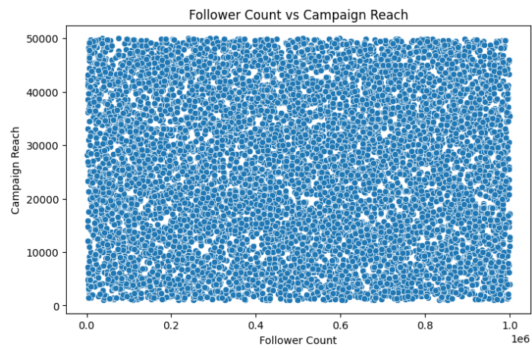
Bar chart:
plt.figure(figsize=(8,5))

sns.countplot(
data=df,
x="Platform"
)

plt.title("Platform Count")

plt.xticks(rotation=45)

plt.show()
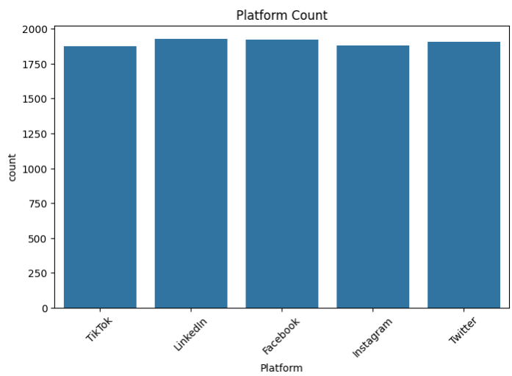
Sub plot:
fig, ax = plt.subplots(1,3, figsize=(15,5))

sns.scatterplot(
data=df,
x="Follower Count",
y="Campaign Reach",
ax=ax[0]
)

ax[0].set_title("Scatter")

sns.boxplot(
data=df,
y="Engagement Rate",
ax=ax[1]
)

ax[1].set_title("Box")

sns.countplot(
data=df,
x="Platform",
ax=ax[2]
)

ax[2].set_title("Count")

plt.tight_layout()

plt.show()
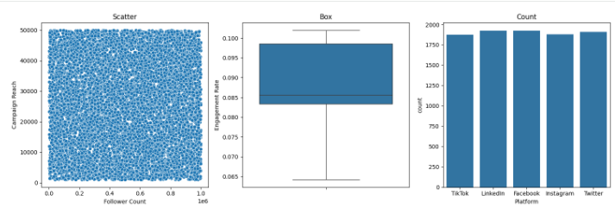

RESULT:
Thus, various visualization techniques such as Line Charts, Bar Charts, Pie Charts, Histograms, Scatter Plots, and Box Plots were successfully created using Matplotlib. The graphical representations helped in understanding trends, distributions, comparisons, and relationships within the dataset.

